Experiment 6
^{Name: Ayush} UID:22bcs15510
Branch: CSE Section/Group:608/A
Semester: 6 DateofPerformance:28/02/25
Subject Name: Java with Lab Subject Code: 22CSH-359

- Aim: Develop Java programs using lambda expressions and stream operations for sorting, filtering, and processing large datasets efficiently.

- Objective:
  - Develop Java programs using lambda expressions and stream operations for sorting, filtering, and processing large datasets efficiently.
  - Implement easy, medium, and hard-level tasks involving sorting employees, filtering and sorting students, and processing products using streams.
- Implementation/Code:
a. import java.util.*; class Employee { String name; int age; double salary;
Employee(String name, int age, double salary) { this.name = name; this.age = age; this.salary = salary;
}
@Override
public String toString() { return name + " - Age: " + age + ", Salary: " + salary;
}
}
public class EmployeeSort { public static void main(String[] args) {
List<Employee> employees = Arrays.asList( new Employee("Ayush", 20, 90000), new Employee("Vinay", 22, 100000),

new Employee("Prakul", 23, 70000)
);
employees.sort(Comparator.comparing(emp -> emp.name)); System.out.println("Sorted by Name: " + employees); employees.sort(Comparator.comparingInt(emp -> emp.age)); System.out.println("Sorted by Age: " + employees); employees.sort(Comparator.comparingDouble(emp -> emp.salary)); System.out.println("Sorted by Salary: " + employees); }
}

b. import java.util.*; import java.util.stream.Collectors; class Student {
private String name; private double marks;
public Student(String name, double marks) {
this.name = name; this.marks = marks;
}
public String getName() {
return name;
}
public double getMarks() {
return marks;
}
}
public class StudentFilter {
public static void main(String[] args) {
List<Student> students = List.of( new Student("Ayush", 85), new Student("Rajeev", 70), new Student("Vinay", 90), new Student("David", 60),
new Student("Prakul", 80)
);

List<String> topStudents = students.stream()
.filter(s -> s.getMarks() > 75)
.sorted(Comparator.comparingDouble(Student::getMarks).reversed())
.map(Student::getName)
.collect(Collectors.toList());
System.out.println("Top Students: " + topStudents); }
}

c. import java.util.*; import java.util.stream.Collectors;
class Product {
String name; String category; double price;
public Product(String name, String category, double price) {
this.name = name; this.category = category; this.price = price;
}
@Override
public String toString() {
return name + " ($" + price + ")";
}
}
public class ProductProcessor {
public static void main(String[] args) {
List<Product> products = Arrays.asList( new Product("Laptop", "Electronics", 1200), new Product("Phone", "Electronics", 800), new Product("TV", "Electronics", 1500), new Product("Shirt", "Clothing", 50), new Product("Jeans", "Clothing", 70), new Product("Blender", "Appliances", 200),
new Product("Toaster", "Appliances", 100)
);

Map<String, List<Product>> productsByCategory = products.stream()
.collect(Collectors.groupingBy(p -> p.category)); System.out.println("Products grouped by category:"); productsByCategory.forEach((category, productList) -> System.out.println(category + ": " + productList));
Map<String, Optional<Product>> mostExpensiveByCategory = products.stream()
.collect(Collectors.groupingBy( p -> p.category,
Collectors.maxBy(Comparator.comparingDouble(p -> p.price))
));
System.out.println("\nMost expensive product in each category:"); mostExpensiveByCategory.forEach((category, product) ->
System.out.println(category + ": " + product.orElse(null))); double averagePrice = products.stream()
.mapToDouble(p -> p.price)
.average()
.orElse(0);
System.out.println("\nAverage price of all products: $" + averagePrice);
}
}

- Output:

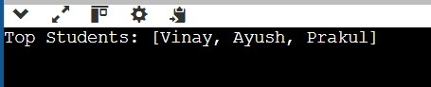

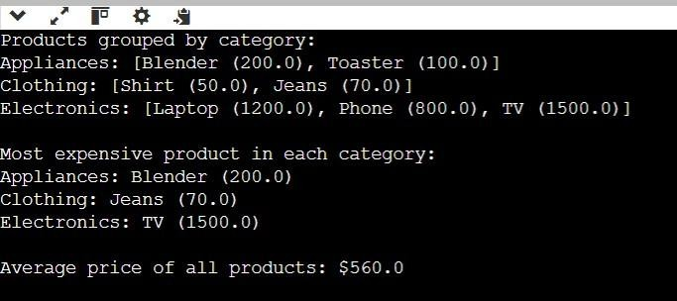

- Learning Outcome:
  - Understand and implement lambda expressions for sorting objects in a list based on different attributes.
  - Utilize Java Streams API to perform operations like filtering, sorting, and mapping efficiently on large datasets.
  - Learn Comparator and method references to simplify object comparisons for sorting.
  - Apply grouping and aggregation functions using Collectors.groupingBy() and Collectors.maxBy() for processing categorized data.
  - Gain hands-on experience in computing statistical values like the average from a dataset using mapToDouble() and average().
  - Improve code efficiency and readability by using functional programming techniques in Java.

